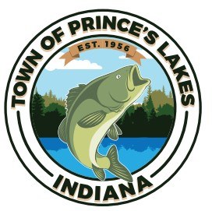 TOWN OF PRINCE’S LAKES TOWN COUNCIL
NOTICE OF SPECIAL MEETING
The Town Council of the Town of Town of Prince’s Lakes, Indiana, at 4:15 pm, on Tuesday, December 12, 2023, will hold a special meeting, as a planning session, to discuss, salary, personnel and staffing needs, and all other business which may come before it. The meeting will be held at the Prince’s Lakes Town Hall, 14 East Lakeview Drive, Prince’s Lakes, IN and will be open to the public.

